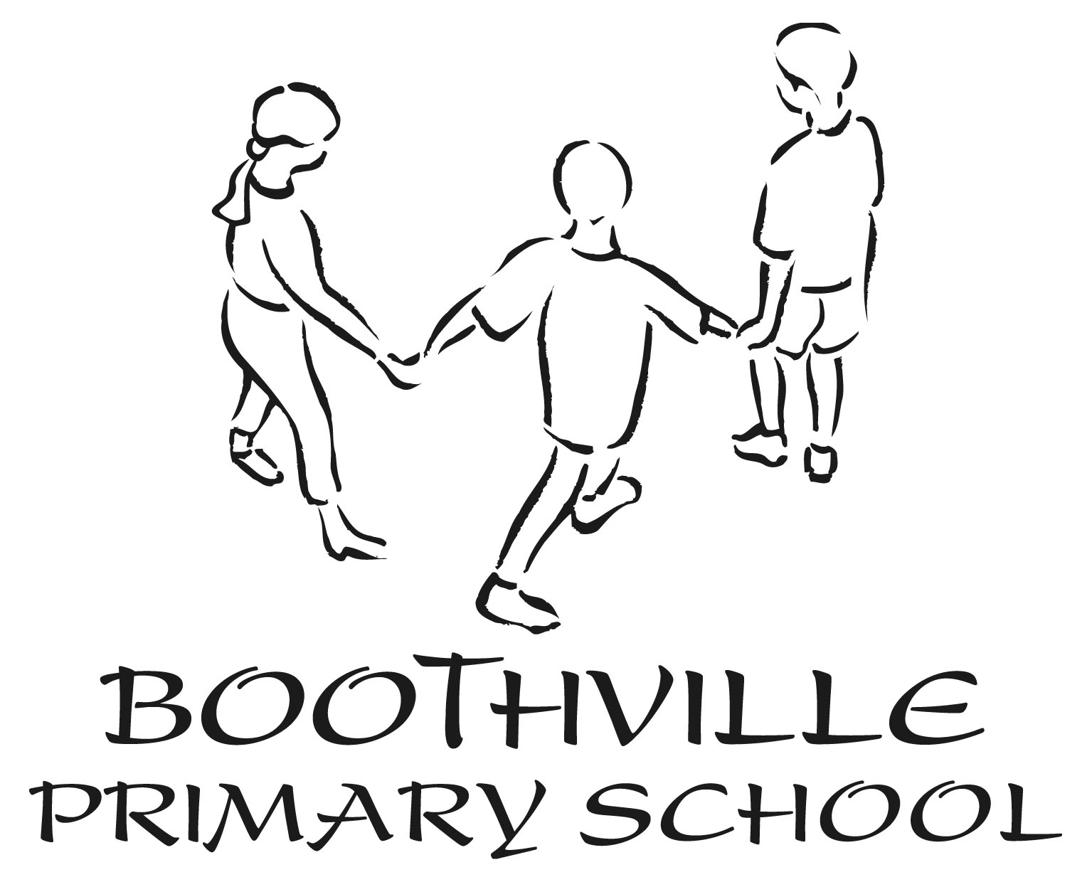

Booth Lane North, Northampton, NN3 6JG
Telephone: 01604 491545 - Fax: 01604 642830
Email: bursar@boothville-pri.northants-ecl.gov.uk

APPLICATION FOR ADMISSION TO BOOTHVILLE PRIMARY SCHOOL NURSERY UNIT

I, the undersigned, wish to apply for a Nursery place for my child as indicated below:
Mon Tues Wed Thur Fri
Morning Session (8:30am–11:30am)
Afternoon Session (12:30pm–3:30pm)
(15 hours free entitlement = 5 sessions, 30 hours free childcare for eligible parents)
30 Hour eligibility Code:_____________________________see–(Gov.uk)
Lunchtime Club (11:30am–12:30pm)
Breakfast Club (7:45am–8:30pm)
After school Club (3:30pm–6:00pm)
(There is a charge for these provisions)

Child’s Surname: _____________________________ Forename: ________________________

Male/Female: ________________________________ Date of Birth: ______________________

Home Telephone Number: ______________________ Mobile: ___________________________

E-mail address:__________________________________________________________________

Address including postcode: _____________________________________________________

______________________________________________________________________________

Name/s and date/s of birth of other children living at home:

If you child has special educational or medical needs please give details below (include any allergies your child may have):
Parents should be aware that our waiting list is sometimes oversubscribed and we are unable to offer places to everyone. Offers are usually made for the term after your child’s 3rd birthday.

If my child is accepted I agree to carry out the rules of the Nursery, to ensure that my child attends regularly and promptly, and to pay each MONDAY MORNING in advance the appropriate sum towards the cost of any extra provisions.

Please print Name (including title): __________________________________________________

Signed: ________________________________________ Date: __________________________
Please return form to the School Office.

